Online Shopping System: FootFusion

Use-Case Specification: Update Payment Methods

Version <1.0>

Revision History
Date | Version | Description | Author
<25/11/2024> | <1.0> | Final Draft | Vũ Trí Nguyện

Table of Contents
1. Use-Case Name 4
1.1 Brief Description 4
2. Flow of Events 4
2.1 Basic Flow 4
2.2 Alternative Flows 4
2.2.1 < First Alternative Flow > 4
2.2.2 < Second Alternative Flow > 5
3. Special Requirements 5
3.1 < First Special Requirement > 5
4. Preconditions 5
4.1 < Precondition One > 5
5. Postconditions 5
5.1 < Postcondition One > 5
6. Extension Points 5
6.1 <Name of Extension Point> 5

Use-Case Specification: Update Payment Methods

Use-Case Name

Brief Description
The purpose of the use case “Update Payment Methods” is to define the steps for editing payment method information within the FootFusion system. The administrator can update existing payment methods efficiently to ensure customers have the latest options available.

Actor
FootFusion Administrator.

Flow of Events

Basic Flow
Administrator selects Payment Methods wanted to update on the table. On the table, the administrator clicks on the “Edit” icon nearby the wanted method or to modify and change the value. The system will navigate admin to the edit page and after the administrator has filled in necessary information and click on “Save changes” button, the system will automatically update the information of that Payment Methods and display on the table
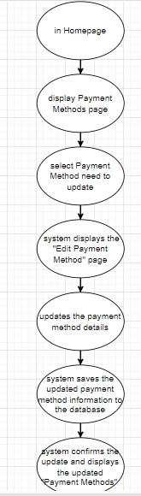

Alternative Flows
None.

Special Requirements
Administrator has basic knowledge of operating computers and user interface.

Preconditions
Administrator is logged in and has at least a user to edit.

Postconditions
The payment methods with changed information is saved to database as well as displayed on the Manage Payment Methods page.

Extension Points
There is no extension point.

Prototype
Figure 1: To update methods, the system will display Checkout screen
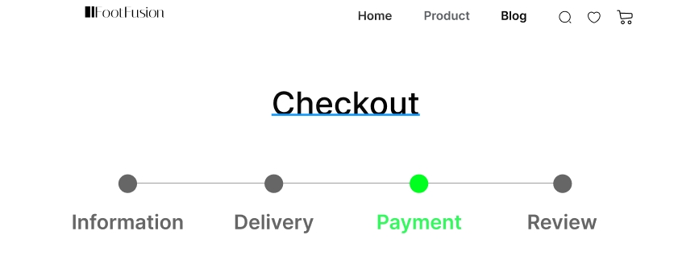

Figure 2: In Payment Method, users can update payment methods by clicking on credit card to add more ways to pay
